**Spring Core Assignment: Load Country from Spring Configuration XML**

**1️ Objective**

Develop a Spring Boot project that:

* Stores country details in a Spring XML configuration.
* Loads and displays the country details using Spring IoC container.
* Logs constructor, getter, and setter method calls.

**2️ Project Details**

* Project Name: springlearn
* Package Name: com.mycompany.myproject
* Bean Config File: country.xml
* Spring Boot Version: Latest stable version (3.x recommended)

**3️ Step-by-Step Implementation**

**Step 1: Create Spring Boot Project**

* Go to [Spring Initializr](https://start.spring.io/)
  + Project: Maven
  + Language: Java
  + Group: com.mycompany.myproject
  + Artifact: springlearn
  + Dependencies: Spring Context
* Click Generate, download and unzip the project.

**Step 2: Add country.xml**

Path: src/main/resources/country.xml  
Content:

<?xml version="1.0" encoding="UTF-8"?>

<beans xmlns="http://www.springframework.org/schema/beans"

xmlns:xsi="http://www.w3.org/2001/XMLSchema-instance"

xsi:schemaLocation="

http://www.springframework.org/schema/beans

http://www.springframework.org/schema/beans/spring-beans.xsd">

<bean id="country" class="com.mycompany.myproject.Country">

<property name="code" value="IN" />

<property name="name" value="India" />

</bean>

</beans>

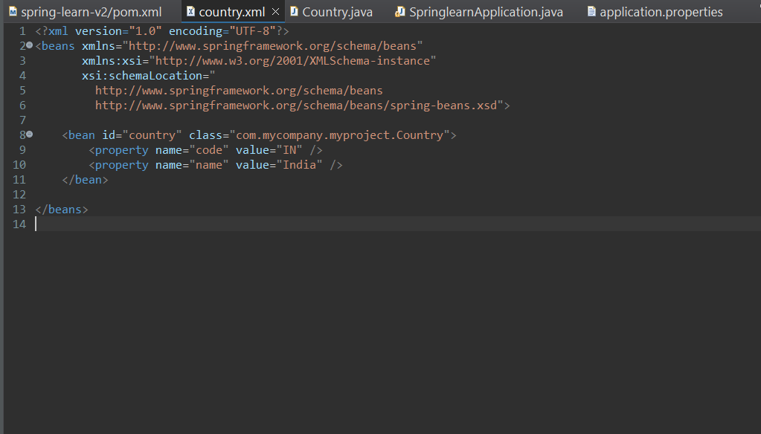

**Step 3: Create Country Class**

Path: src/main/java/com/mycompany/myproject/Country.java  
Content:

package com.mycompany.myproject;

import org.slf4j.Logger;

import org.slf4j.LoggerFactory;

public class Country {

private static final Logger LOGGER = LoggerFactory.getLogger(Country.class);

private String code;

private String name;

public Country() {

LOGGER.debug("Inside Country Constructor.");

}

public String getCode() {

LOGGER.debug("Inside getCode()");

return code;

}

public void setCode(String code) {

LOGGER.debug("Inside setCode()");

this.code = code;

}

public String getName() {

LOGGER.debug("Inside getName()");

return name;

}

public void setName(String name) {

LOGGER.debug("Inside setName()");

this.name = name;

}

@Override

public String toString() {

return "Country [code=" + code + ", name=" + name + "]";

}

}

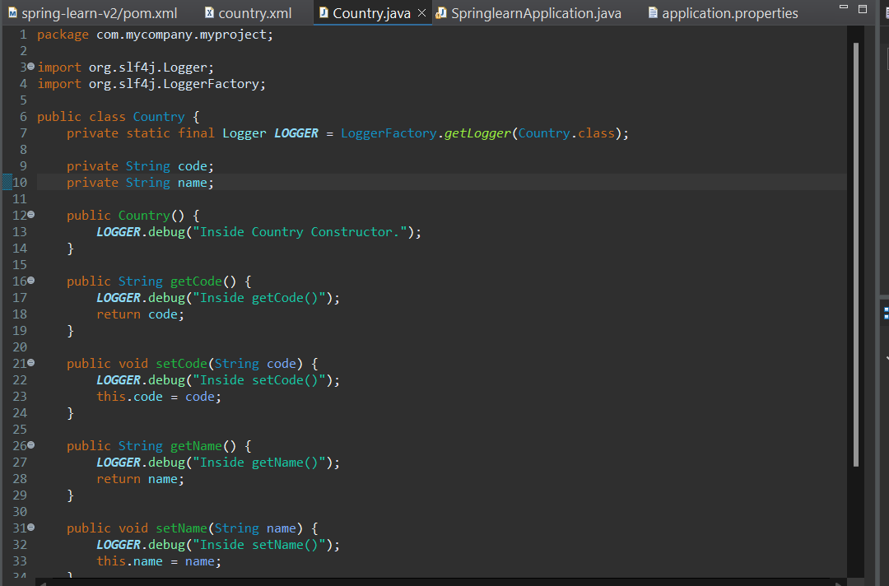

**Step 4: Update SpringlearnApplication**

Path: src/main/java/com/mycompany/myproject/SpringlearnApplication.java  
Content:

package com.mycompany.myproject;

import org.slf4j.Logger;

import org.slf4j.LoggerFactory;

import org.springframework.boot.SpringApplication;

import org.springframework.boot.autoconfigure.SpringBootApplication;

import org.springframework.context.ApplicationContext;

import org.springframework.context.support.ClassPathXmlApplicationContext;

@SpringBootApplication

public class SpringlearnApplication {

private static final Logger LOGGER = LoggerFactory.getLogger(SpringlearnApplication.class);

public static void main(String[] args) {

SpringApplication.run(SpringlearnApplication.class, args);

displayCountry();

}

public static void displayCountry() {

ApplicationContext context = new ClassPathXmlApplicationContext("country.xml");

Country country = context.getBean("country", Country.class);

LOGGER.debug("Country : {}", country.toString());

}

}

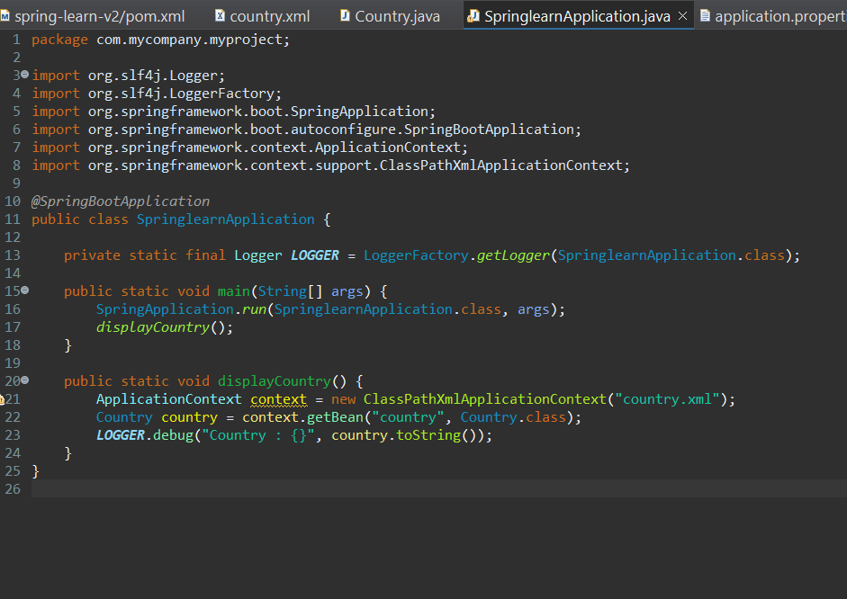

**Step 5: Build & Run**

* Right-click SpringlearnApplication → Run main method.
* Observe logs in the console:
* Inside Country Constructor.
* Inside setCode()
* Inside setName()
* Country : Country [code=IN, name=India]

